# CONFIGURATION OF SONAR IN ANGULAR PROJECT

TABLE OF CONTENTS

Introduction 3

What is Sonar? 3

Why Sonar? 3

Implementation 5

Result 8

Conclusion 9

Mohamed Ajmeer Kaja M

# Introduction

When Developers develop an Angular Project, the source code should be simple, readable, Flexible, Testable and everything should be covered under Tests. For this, Developers need to perform static code analysis on an Angular Project. By using static code analysis, you can help developers find errors before they compile or run the code and alert them about any other issues, such as a lack of inline documentation, bad coding standards, security issues, performance issues, and so on. SonarQube was an easy choice for us since it provides all the above with a nice UI. It can also drill down and check the coverage vs tech-debt graph for each file in the project.

# What is SonarQUBe?

SonarQube formerly called Sonar is an open-source platform developed by SonarSource for continuous inspection of code quality to perform automatic reviews with static analysis of code to detect bugs and code smells on 29 programming languages. SonarQube offers reports on duplicated code, coding standards, unit tests, code coverage, code complexity, comments, bugs, and security recommendations.

SonarQube can record metrics history and provide evolution graphs. SonarQube provides fully automated analysis and integration with Maven, Ant, Gradle, MS Build and continuous integration tools

## Why SonarQube?

* Collects and analyses Code Quality
* Offers report on Duplicate Code.
* Offers Code Coverage report.
* Super fast analysis
* Automatic Analysis

# IMPLementation

## Step 1: Install SonarQube and Sonar Scanner

* Download SonarQube from their Official Site
  + <https://www.sonarqube.org/downloads/>
* Download Sonar Scanner from their Official Site
  + <https://docs.sonarqube.org/latest/analysis/scan/sonarscanner/>

## Step 2: Modify Configuration

* Navigate to SonarQube->conf->sonar.properties to modify SonarQube configuration.

* Modify the **sonar.web.port = 9099** in sonar.properties file.
* Navigate to Sonarscanner->conf->sonar-scanner.properties to modify Sonar Scanner Configuration.

* Add **sonar.host.url =** [**http://Localhost:9099**](http://Localhost:9099) in sonar-scanner.properties file.

## Step 3 : Start the SonarQube

* Open the path SonarQube->bin->windows-x86-64 and run SonarStart.bat

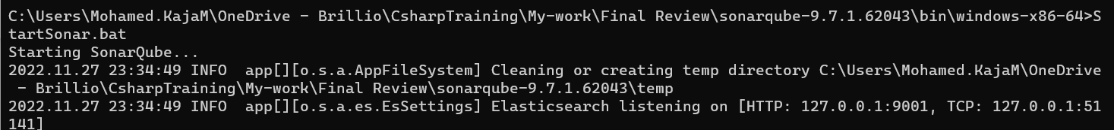

* Open the browser and go to <http://localhost:9099>

* For the first time the Username and password is “admin”. You need to update the password.
* Then the SonarQube Runs on the port 9099.

## Step 4: Add SonarCube plugin to karma.conf

* Run the following command in the project directory to install karma-sonarqube-reporter.

## 

Open the karma.conf.js and make the following changes

1. Import the plugin

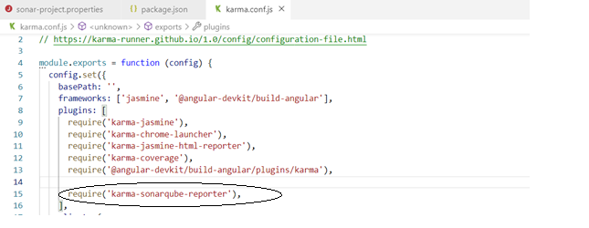

1. Add Sonarqube to the array of reporters in karma.conf.

` 

1. Configure Sonarqube in karma.conf.

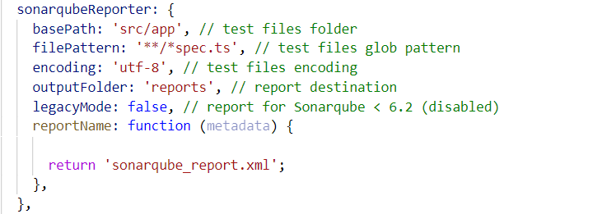

## Step 5: Configure SonarQube with you Angular Project

* Run the following Command in your project directory to configure the sonarqube with the angular project.

**npm install sonar-scanner --save-dev**

## Step 6: Create sonar property file in your Angular Project

* Create a file called sonar-project.properties in your Angular root directory and add the below attributes in the same file.

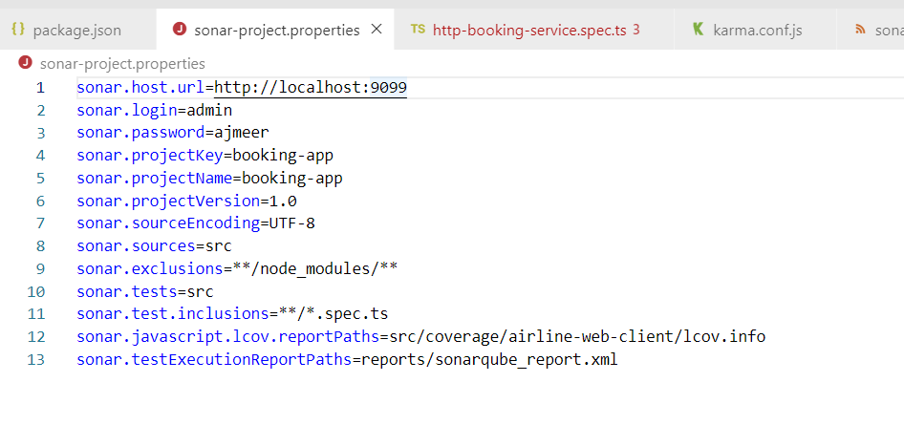

## Step 6: Add Script to run

* Add a script called sonar to your package.json.

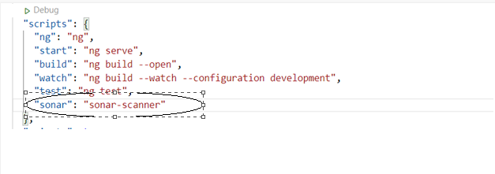

## Step 7: Sonar Run

Run the Sonar



## Result:

* Once the build is done it will provide dashboard link that provides the analysis report.

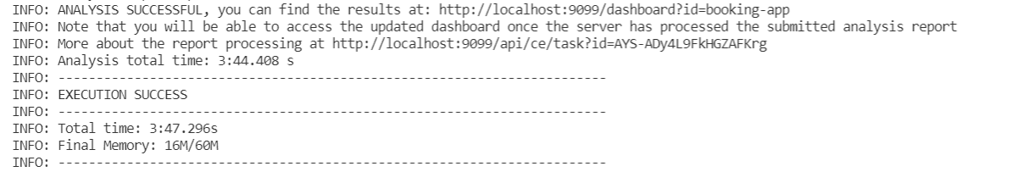

* Open the link and see the analysis result.

# Conclusion

Thus, SonarQube provides a platform that significantly increases the lifetime of applications by reducing complexities, duplications and potential bugs in the code, by keeping neat and clean code architecture and increased unit tests. SonarQube increases maintainability of the software.